CSRF token

🛡️ What Is a CSRF Token?
# Source: Chatgpt (GPT-5-Mini) at [1/20/2026]
CSRF Token stands for Cross-Site Request Forgery Token.
It is a security token used to protect web forms from malicious requests sent without the user’s knowledge — usually from another site.

✅ Simple Definition:
# Source: Chatgpt (GPT-5-Mini) at [1/20/2026]
A CSRF token is a hidden, random value included in forms to verify that the request came from the real user, not an attacker.

🧠 Real-Life Analogy:
# Source: Chatgpt (GPT-5-Mini) at [1/20/2026]
Imagine a safety code on the back of your credit card.
Even if someone steals your card number, they can’t complete a purchase without the code.
A CSRF token is like that secret code for a form submission.

❗ What Is CSRF Attack?
# Source: Chatgpt (GPT-5-Mini) at [1/20/2026]
A Cross-Site Request Forgery (CSRF) attack tricks a logged-in user into unknowingly submitting a malicious request to a trusted site.

Example:
# Source: Chatgpt (GPT-5-Mini) at [1/20/2026]
If you are logged into your bank, and visit a malicious website, it could secretly submit:
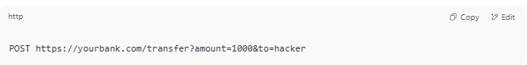
POST https://yourbank.com/transfer?amount=1000&to=hacker

💣 Without a CSRF token, the bank might process it — thinking it came from you.

🔐 How CSRF Tokens Prevent That
# Source: Chatgpt (GPT-5-Mini) at [1/20/2026]
- 🧾 Server generates a unique CSRF token for each user session.
- 🔒 The token is placed in a hidden input of every form.
- ✉️ When the form is submitted, the token is sent with it.
- ✅ Server validates the token — if it’s missing or incorrect, the request is rejected.

🧾 Example (Form with CSRF Token):
# Source: Chatgpt (GPT-5-Mini) at [1/20/2026]
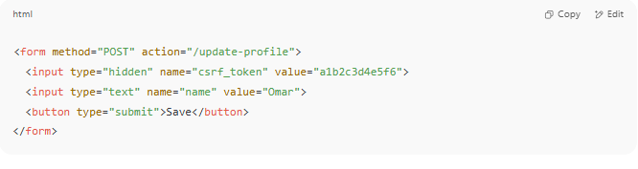
<form method="POST" action="/update-profile">
<input type="hidden" name="csrf_token" value="a1b2c3d4e5f6">
<input type="text" name="name" value="Omar">
<button type="submit">Save</button>
</form>

🔐 In PHP (Very Basic Example):
# Source: Chatgpt (GPT-5-Mini) at [1/20/2026]
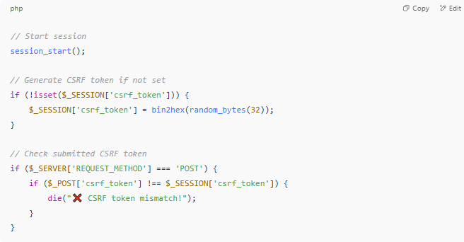

// Start session
session_start();

// Generate CSRF token if not set
if (!isset($_SESSION['csrf_token'])) {
$_SESSION['csrf_token'] = bin2hex(random_bytes(32));
}

// Check submitted CSRF token
if ($_SERVER['REQUEST_METHOD'] === 'POST') {
if ($_POST['csrf_token'] !== $_SESSION['csrf_token']) {
die("❌ CSRF token mismatch!");
}
}

🧰 Frameworks That Handle CSRF Automatically
# Source: Chatgpt (GPT-5-Mini) at [1/20/2026]
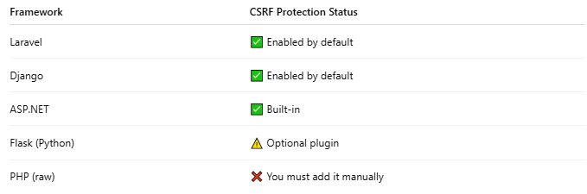

Framework | CSRF Protection Status
Laravel | ✅ Enabled by default
Django | ✅ Enabled by default
ASP.NET | ✅ Built-in
Flask (Python) | ⚠️ Optional plugin
PHP (raw) | ❌ You must add it manually

✅ Why CSRF Tokens Are Important
# Source: Chatgpt (GPT-5-Mini) at [1/20/2026]
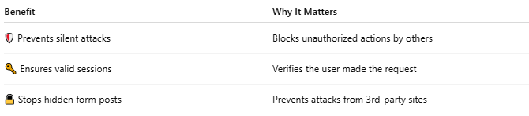

Benefit | Why It Matters
🛡 Prevents silent attacks | Blocks unauthorized actions by others
🔑 Ensures valid sessions | Verifies the user made the request
🔒 Stops hidden form posts | Prevents attacks from 3rd-party sites

⚠️ CSRF Token vs JWT vs Session ID
# Source: Chatgpt (GPT-5-Mini) at [1/20/2026]
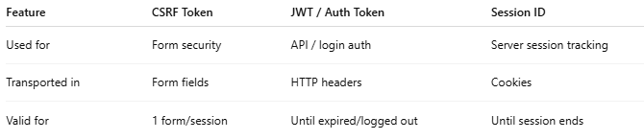

Feature | CSRF Token | JWT / Auth Token | Session ID
Used for | Form security | API / login auth | Server session tracking
Transported in | Form fields | HTTP headers | Cookies
Valid for | 1 form/session | Until expired/logged out | Until session ends

